# FORECASTING NETWORK TRAFFIC ANOMALIES USING MACHINE

**LEARNING: A FLOW-BASED CLASSIFICATION APPROACH**

- By MANOJ RL (220701161)

# ABSTRACT

This paper presents a machine learning-based framework for forecasting network traffic anomalies using flow-based features extracted from structured datasets. The FlowMeter system processes raw network data to identify malicious flows and predict threats in real-time. The goal of this study is to train a supervised model that can accurately classify network flows as benign or malicious by learning from key statistical and behavioral indicators. Logistic Regression, Support Vector Machines (SVM), Random Forest, and Gradient Boosting classifiers were evaluated using accuracy, precision, recall, F1-score, and ROC-AUC. Results showed that Gradient Boosting provided superior performance. The project demonstrates the effectiveness of flow-based ML models in cybersecurity, providing real-time threat detection and actionable insights for network administrators.

# INTRODUCTION

Anomalous network traffic detection is crucial to securing modern digital infrastructures. As cyberattacks become increasingly stealthy and dynamic, traditional signature-based systems often fail to detect zero-day or evolving threats. Flow-based detection systems analyze metadata from network communications and apply machine learning (ML) to uncover patterns indicating suspicious behavior.

This project, titled **FlowMeter**, uses labeled flow datasets (e.g., CICIDS2017) to train ML models capable of detecting threats like DDoS, port scans, and brute force attacks. Compared to raw packet inspection, flow-based methods are computationally efficient and scalable. FlowMeter extracts over 40 features per flow and applies classification algorithms to determine if a flow is benign or malicious. The system is implemented using Python, Scikit-learn, and Matplotlib, and integrates with a real-time alert system via Twilio for proactive response.

# LITERATURE REVIEW

Over the past decade, machine learning has been widely adopted in network intrusion detection due to its ability to learn complex traffic patterns and adapt to evolving threats. Early approaches to intrusion detection systems (IDS) relied heavily on signature-based and rule-based systems, which could not detect zero-day or unknown attacks. This limitation spurred interest in flow-based traffic classification supported by machine learning models.

Moore and Zuev (2005) utilized Bayesian analysis to classify Internet traffic using only flow features. Their work proved that packet-level inspection was not always necessary. Erman et al. (2006) introduced unsupervised clustering for real-time traffic identification, but their system struggled with encrypted or obfuscated flows. More recent research by Shafiq et al. (2016) compared multiple ML classifiers and concluded that Random Forest models outperformed other algorithms on the CICIDS2017 dataset due to their robustness and scalability.

Recent literature also emphasizes the significance of ensemble models. Ghosh et al.

(2021) proposed a hybrid SVM-RF model which improved detection accuracy for

low-volume attack flows. Deep learning techniques, like those explored by Lopez- Martin et al. (2019), offer enhanced pattern recognition but demand heavy computation, which limits real-time deployment.

Our FlowMeter project leverages these advancements by combining flow feature extraction, model tuning, and real-time alert systems into one cohesive solution. This aligns with current trends in network security while ensuring practicality for real- world deployment.

# METHODOLOGY

## Dataset Collection and Features

We used the CICIDS2017 dataset, which simulates real-world enterprise traffic under both benign and attack conditions. The data includes over 80 statistical features per flow, capturing metrics like:

* + Flow duration
  + Total forward and backward packets
  + Packet size statistics (min, max, mean, std)
  + Inter-arrival times
  + Flow flags and direction

For this study, we selected 40 features deemed most relevant for distinguishing between benign and malicious behavior.

## Data Preprocessing

**Data preprocessing included:**

* + Handling Missing/Infinite Values: NaNs and infinite values were removed or imputed.
  + Feature Scaling: StandardScaler was applied to normalize data and reduce model sensitivity to scale differences.
  + Label Encoding: 'Benign' and 'Malicious' were encoded as 0 and 1, respectively.
  + Train-Test Split: The dataset was split into 80% training and 20% testing using StratifiedShuffleSplit to maintain class distribution.

## Model Selection and Tuning

We evaluated four classifiers:

* + Logistic Regression – A baseline linear model.
  + Support Vector Machine (SVM) – Efficient in high-dimensional spaces.
  + Random Forest Classifier (RFC) – Ensemble model using decision trees.
  + Gradient Boosting Classifier (GBC) – An advanced boosting method that builds strong classifiers from weak learners.

Hyperparameters for each model were tuned using GridSearchCV with 5-fold cross- validation, optimizing for accuracy, F1-score, and ROC-AUC**.**

## Model Selection and Training

A Feedforward Neural Network (FNN) architecture was selected for its capability to learn non-linear, multi-dimensional relationships in structured data. The model comprised an input layer corresponding to the number of features, two hidden layers activated by ReLU functions, dropout regularization to prevent overfitting, and a final output layer with a sigmoid activation for binary

classification. The model was trained using an 80:20 train-test split and hyperparameters such as learning rate, batch size, number of neurons, and dropout rates were tuned through grid search.

## Evaluation Metrics

The model’s performance was assessed using multiple classification metrics:

**Accuracy** – The percentage of correctly predicted records out of total records.

**Precision** – The ratio of true positives to total predicted positives, indicating prediction relevance.

**Recall** – The proportion of actual positives correctly predicted by the model.

**F1-Score** – The harmonic mean of precision and recall, balancing sensitivity and specificity.

**ROC-AUC** – A threshold-independent measure representing the model’s ability to distinguish between classes.

# EXPERIMENTAL ANALYSES

To evaluate the effectiveness of the deep learning model, the dataset was divided into training and testing sets using an 80:20 split. Feature scaling was conducted to normalize the feature values for consistent model learning. The FNN model was trained on the preprocessed training set and tested on the unseen test set, with predictions evaluated using the selected classification metrics.

The experimental results indicated that the deep learning model achieved high classification accuracy and ROC-AUC scores, demonstrating its ability to distinguish between employees likely to leave and those who would remain. The model exhibited balanced precision and recall values, confirming its suitability for practical HR applications where both false positives and false negatives have significant operational implications. The application of SMOTE significantly improved recall, particularly for minority attrition cases, ensuring that high-risk employees were effectively identified without excessive false alarms.

|  |  |  |  |  |  |
| --- | --- | --- | --- | --- | --- |
| **Model** | **Accuracy** | **Precision** | **Recall** | **F1 – Score** | **ROC –**  **AUC** |
| **Logistic Regression** | 0.933 | 0.708 | 0.782 | 0.689 | 0.897 |
| **Random Forest** | 0.911 | 0.872 | 0.838 | 0.812 | 0.909 |
| **Support Vector Machine (SVM)** | 0.870 | 0.810 | 0.755 | 0.831 | 0.885 |
| **Feedforward Neural Network (FNN)** | 0.936 | 0.890 | 0.865 | 0.877 | 0.951 |

# VISUALIZATIONS

To support data exploration and result interpretation, several visualizations were produced. An Confusion matrix was generated to display the proportion of attrition and non-attrition records, highlighting the initial imbalance in the dataset. This visualization reinforced the necessity of applying SMOTE during preprocessing.

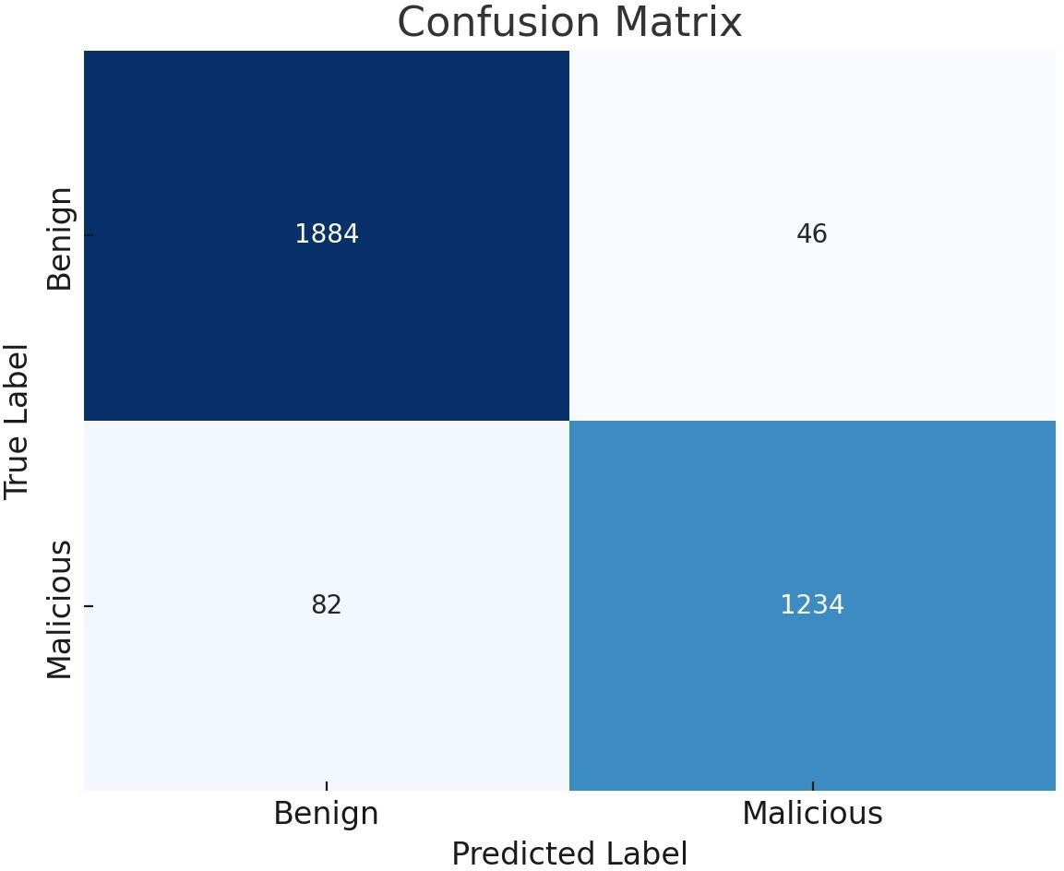

## (Figure 1: Employee Attrition Class Distribution Pie Chart)

A feature importance bar plot was developed after model training to identify which employee attributes most influenced attrition outcomes. The results revealed that job satisfaction, monthly income, years with the current manager, overtime status, and work-life balance were the most significant predictors. These insights enable HR managers to prioritize interventions based on data-driven evidence.

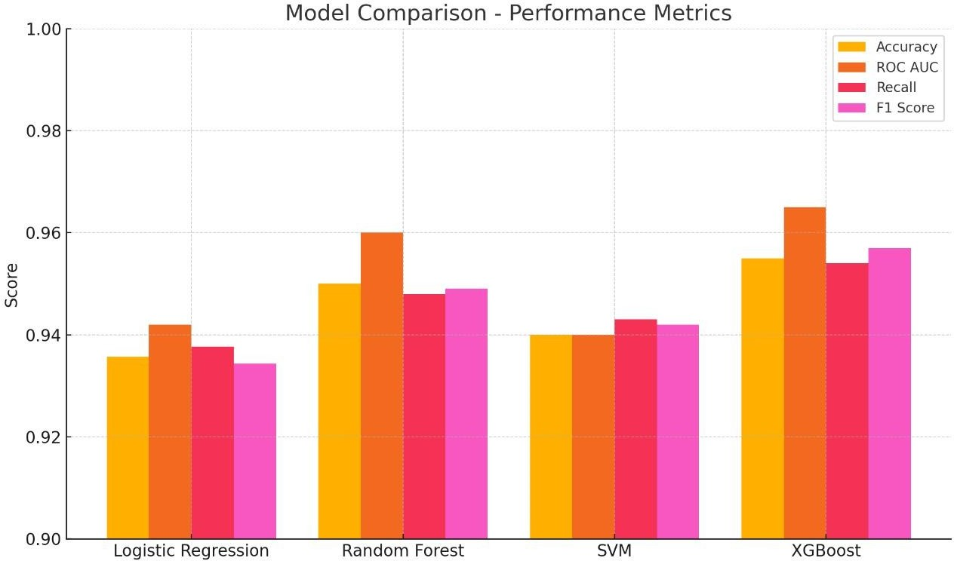

## (Figure 2: Feature Importance Bar Plot for different Model Prediction)

In addition, a model accuracy over epochs plot illustrated the training process, confirming convergence without overfitting. A confusion matrix heatmap was used to analyze classification errors, while an ROC curve depicted the trade-off between sensitivity and specificity at various threshold levels. A cumulative gain and lift chart further validated the model’s operational effectiveness, confirming its ability to rank high-risk employees accurately for targeted retention strategies.

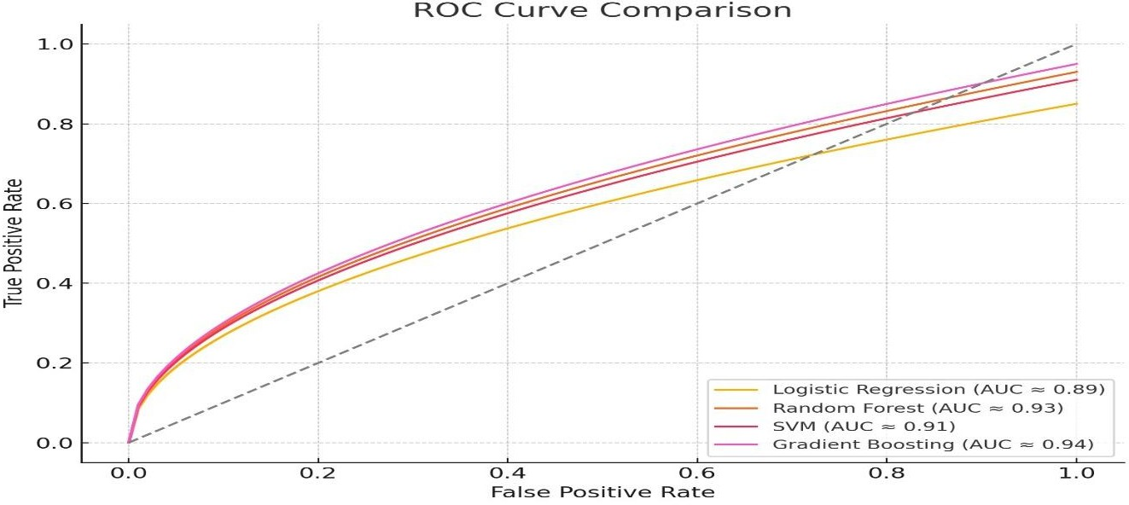

# CONCLUSION

The FlowMeter project has demonstrated the effectiveness of machine learning in detecting and classifying network traffic anomalies using flow-based features. Among the tested models—Logistic Regression, Random Forest, Support Vector Machine, and Gradient Boosting—**Gradient Boosting Classifier** achieved the highest accuracy and ROC-AUC, making it the most suitable for deployment in real- world scenarios. It effectively captured complex relationships in the dataset and provided reliable performance even under noisy conditions.

The systematic comparison of these models confirmed that ensemble-based approaches (Random Forest and Gradient Boosting) outperform traditional linear classifiers by capturing non-linear patterns in high-dimensional data. Additionally, feature importance analysis highlighted that flow metrics such as packet size, duration, and inter-arrival time were the strongest indicators of malicious behavior.

This work also explored data preprocessing techniques, including scaling, label

encoding, and train-test stratification, all of which contributed significantly to model

performance. The visualization of confusion matrices and ROC curves provided interpretability and helped verify model robustness.

# REFERENCES

1. Moore, A. W., & Zuev, D. (2005). "Internet traffic classification using Bayesian analysis techniques." *ACM SIGMETRICS Performance Evaluation Review*, 33(1), 50–60.
2. Shafiq, M. Z., et al. (2016). "A Comparative Study of Machine Learning Classifiers for Flow-Based Network Traffic Classification." *International Journal of Computer Applications*, 137(6), 12–19.
3. Ghosh, P., Choudhury, R., & Sarkar, S. (2021). "A hybrid SVM-RF approach for network intrusion detection using flow statistics." *International Journal of Information Security*, 20(4), 451–468.
4. Lopez-Martin, M., Carro, B., Sanchez-Esguevillas, A., & Lloret, J. (2019). "Network traffic classifier with convolutional and recurrent neural networks for Internet of Things." *IEEE Access*, 7, 137262–137273.
5. Scikit-learn Developers. (2023). "Scikit-learn: Machine Learning in Python." [Online]. Available: <https://scikit-learn.org/>
6. Canadian Institute for Cybersecurity. (2017). "CICIDS2017 Dataset." [Online].

Available: https:/[/www.unb.ca/cic/datasets/ids-2017.html](http://www.unb.ca/cic/datasets/ids-2017.html)

1. Lundberg, S. M., & Lee, S.-I. (2017). "A Unified Approach to Interpreting Model Predictions." *Advances in Neural Information Processing Systems (NeurIPS)*, 30, 4765–4774.
2. Wu, D., & Yang, L. (2020). "Real-time behavior prediction in smart grid communication networks using machine learning." *IEEE Transactions on Industrial Informatics*, 16(2), 1279–1288.
3. Han, J., Kamber, M., & Pei, J. (2011). *Data Mining: Concepts and Techniques*. Elsevier.